
*Note to Schools’ Fencing League Administrators
You may use this form to enter fencers for all three weeks of preliminaries.
You can add fencers at any time up to the Thursday prior to a round. Contact Bill if unsure: 0403 267 330

Term 4, 2019 Individual Epee Competitions
ENTRY FORM* Email to Bill Ronald by Thursday prior to event: mailto:deploy@tpg.com.au
School: |  |  | Contact name: |  | Contact phone:
Date | Start | Under 14 |  | Under 16 | Under 19
26 October | 8:30 am |  |  | One round of pools Entries | One round of pools Entries
2 November | 8:30 am | One round of pools Entries |  |  | One round of pools Entries
9 November | 8:30 am | One round of pools Entries |  | One round of pools Entries
16 November | 8:00 am | Direct elimination |  | Direct elimination | Direct elimination
FORMAT
- The first three (3) weekends will be pool rounds where seeding for the first weekend will be based on the results of the Term 2 Epee Team Premiership and any available state/national ranking.
- Seeding for the second weekend will be based on the result of the first weekend.
- Seeding for the direct elimination will be based on the result of the second weekend.
- Time allocation for each round of pools: 1.5 hours
- 5 hit bouts 3 mins, 15 hits / 3 mins / 3 periods
- Time allocation for direct eliminations: 1.5 to 2 hours, depending on final number of fencers
- All fencers must arrive at least 30 minutes before the indicated start time to help set up and warm up.

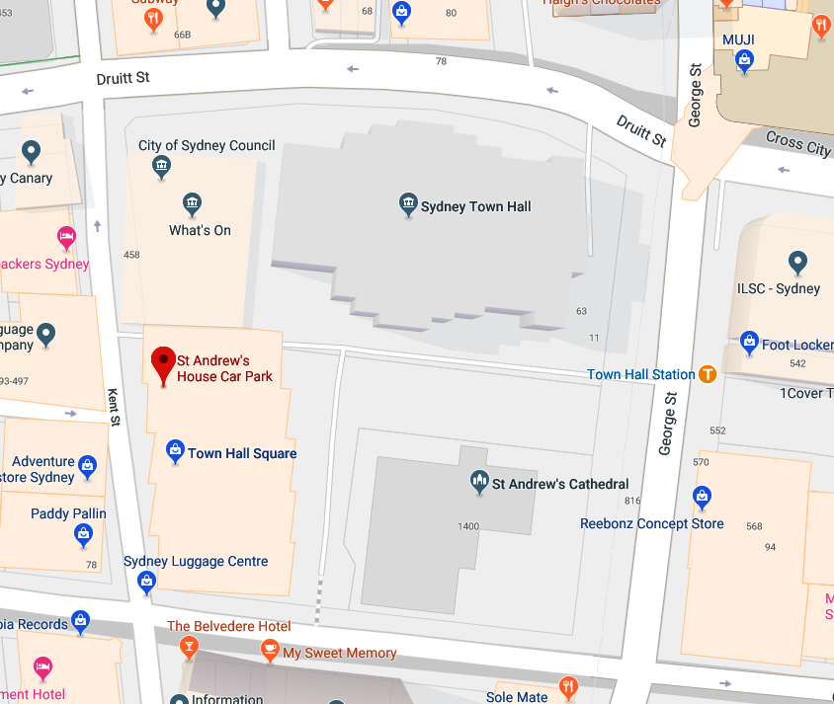
Venue and contact details:
St Andrew’s Cathedral School (SACS)
Contact person: Bill Ronald (Head Coach)
Email: deploy@tpg.com.au
Phone number: 0403 267 330
Venue location: St Andrew’s House - It is behind St Andrew’s Cathedral and next to Sydney Town Hall. The Gym is on the 7th floor. Please wait at the entrance and the SACS teacher in charge will open the door and provide lift access.
Address: Sydney Square, 474 Kent St, Sydney NSW 2000
Parking: Paid parking under the school c/o Wilson Parking (St Andrews House - Town Hall Car Park), 464 Kent Street, Sydney. Weekend fixed rate $15
https://www.wilsonparking.com.au/park/2202_St-Andrews-House---Town-Hall-Car-Park_464-Kent-Street-Sydney
Highly recommend coming by public transport.
Public Transport: Town Hall railway station is just metres away

