

The 2022 League Epee Program will consist of individual and team rounds to decide:
- Individual Champions by age
- Championship Teams by School by age group,
- Championship School by points awarded in individual and team
The age groups for the NSW School Fencing League are:
- Under 14 – born in 2008 or later
- Under 16 – born in 2006 or 2007
- Under 19 – born in 2005 or earlier
The fixtures, dates, and venues are:
 | Individual Round 1 | Individual Round 2 | Individual Round 3 | Individual Medal Rounds | Teams 1 | Teams 2 | AJ Rae  NSWFA
 | 2/4/2022 | 30/4/2022 | 7/5/2022 | 14/5/2022 | 21/05/2022 | 30/07/2022 | 28/5 Inter  4/6 Senior  NSW Fencing Centre
Host Venue | Venue SACS  (St Andrews) | Venue SACS | Venue SACS | Venue SAC  (St Aloysius’College) | TBC | TBC | 28/5 Inter  4/6 Senior  NSW Fencing Centre
Event 1  8:00am to 9:30am | U16  Round 1  Pools A,B,C,D,E,F | U19  Round 2  Pools  A,B,C,D,E,F | U14  Round 2  Pools  A,B,C,D,E,F | D/E round of 16  U14 8:00 | U14 | U14 | NSWSFL is allowing for its teams to participate in the National Qualifier  AJ Rae.  Entries through NSWFA
Event 2  10:00 am to 11:30 | U19  Round 1  Pools A,B,C,D,E,F | U14  Round 1  Pools A,B,C,D,E,F | U16  Round 2  Pools A,B,C,D,E,F | D/E round of 16  U16 9:00 | U16 | U16
 |  |  |  | D/E round of 16  U19 10:00 | U19 | U19

Suppositions

COMPETING SCHOOLS: Epee Schools will be invited to consider the new accessible format
- SBHS
- Aloys
- SACS
- Barker
- Oxley
- Abbotsleigh

PARTICIPATION
Individual:
- Entries will be made by participating NSWSFL schools
- The League requires a release for non NSWSFL fencers
- Individual entries are maximum 36 (6 pools x 6)
- Schools will nominate entry number
- Each participating school (x) is entitled to 36 ÷ x places
- Untaken places will be allocated to those with unfilled lists, pro rata
- Schools seed initial entries, there is a re-seed after each round based on V/M and Indicator
Team: A school may enter in any or all age groups.
- Schools may enter 2 teams of 3+1 per age group
- Format of teams will be determined after entries received
- Intention is that each school will compete against each other school over 2 weeks of team event
FACILITIES: Host schools to provide 6 pistes for competition
* Entry fee: $100 per competing school in the program. An individual may enter for $25 fee. The permission form must be completed.

Venue and contact details:
- St Andrew’s Cathedral School (SACS)
Contact person: Bill Ronald (Head Coach)
Email: deploy@tpg.com.au
Phone number: 0403 267 330
Venue location: St Andrew’s House - It is behind St Andrew’s Cathedral and next to Sydney Town Hall. The Gym is on the 7th floor. Please wait at the entrance and the SACS teacher in charge will open the door and provide lift access.
Address: Sydney Square, 474 Kent St, Sydney NSW 2000
Parking: Paid parking under the school at Wilson Parking (St Andrews House - Town Hall Car Park), 464 Kent Street, Sydney. Weekend fixed rate $15
https://www.wilsonparking.com.au/park/2202_St-Andrews-House---Town-Hall-Car-Park_464-Kent-Street-Sydney
Highly recommend coming by public transport.
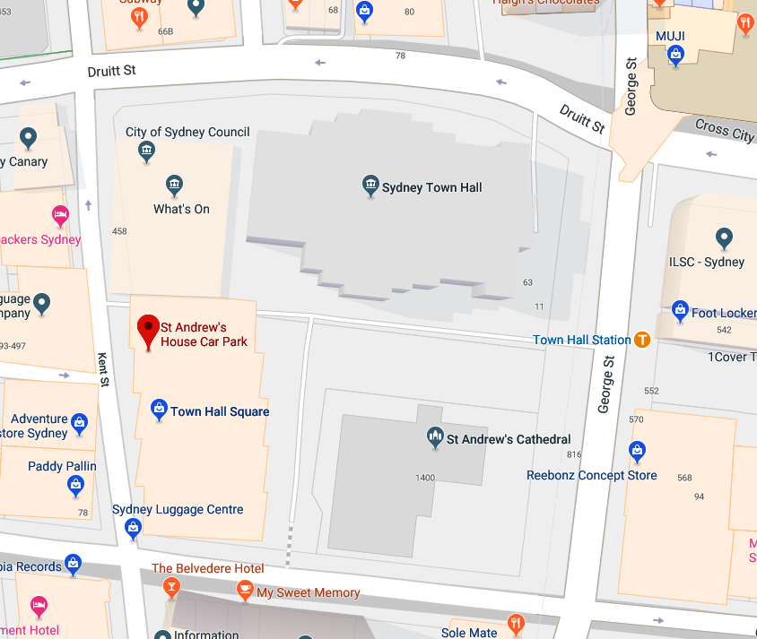
Public Transport: Town Hall railway station is just metres away.

- StAloysius’College(SAC)
Contact person: Edwin Lapitan (Parent Fencing Manager)
Email: Edwin.Lapitan@intl.att.com
Phone number: 0410 463 517
Venue location: Great Hall, entrance through Jeffreys St or Kirribilli Ave (arrows) Address: 47 Upper Pitt St, Kirribilli NSW 2061
Parking: Students advised to be dropped off or take public transport. Limited street parking nearby – 2P parking on Kirribilli Ave., Pitt St., Broughton St., and north portion of Jeffreys St.; metered parking (2P, 4P and 8P) on Olympic Drive; 1P parking elsewhere.
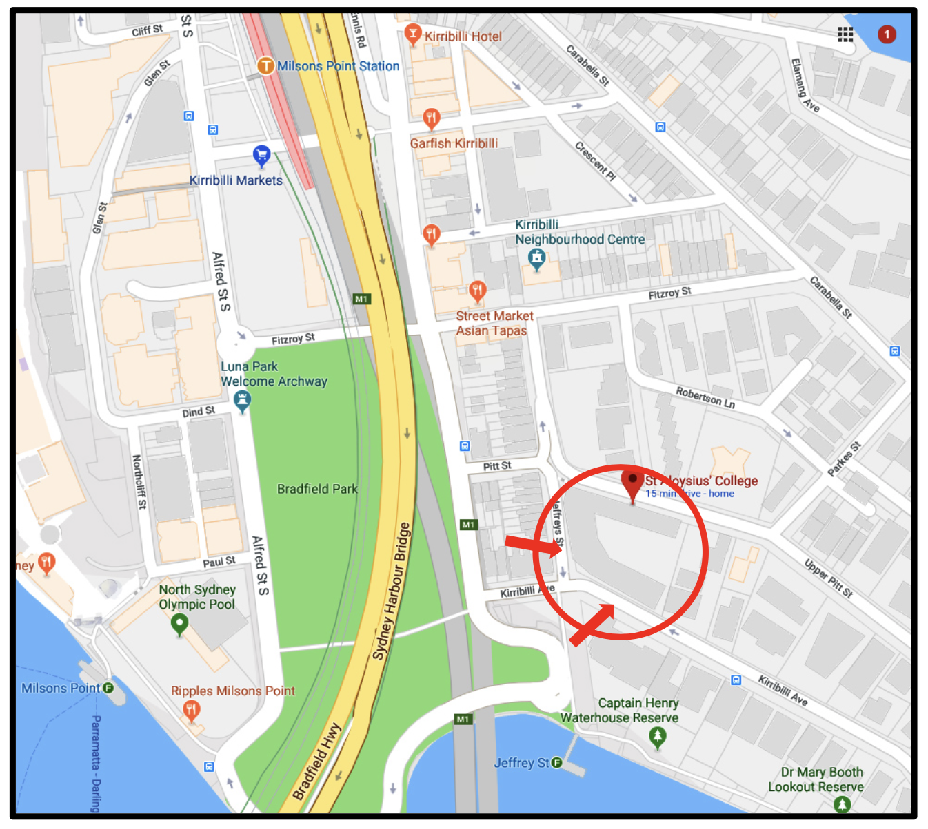
Public Transport: Milsons Point Train Station nearby. Various bus routes nearby.

