
PLEASE RETURN ASAP but by: CLOSE OF BUSINESS WEDNESDAY 22 APRIL 2026 (Individual)
CLOSE OF BUSINESS WEDNESDAY 27 MAY 2026 (TEAM)
Email to Epee Co-ordinator: Bill Ronald deploy@tpg.com.au (0403 267 330)

Entry for School:

Contact Name: |  | Email: |  | Mobile:

seed | 14 INDIVIDUAL (seeded) | 14 TEAM |  | YES |  | NO
1 |  | 1 | (Names due 1 week prior to week 0ne)
2 |  | 2
3 |  | 3
4 |  | 4
5 |  | 5 | Entries 7 – 8 are subject to TOTAL entries not exceeding 42 (6 POOLS OF 7)
6
7
8
seed | 16 INDIVIDUAL (seeded) | 16 TEAM |  | YES |  | NO
1 |  | 1 | (Names due 1 week prior to week 0ne)
2 |  | 2
3 |  | 3
4 |  | 4
5 |  | 5 | Entries 7 – 8 are subject to TOTAL entries not exceeding 42 (6 POOLS OF 7)
6
7
8
seed | 19 INDIVIDUAL (seeded) | 19 TEAM |  | YES |  | NO
1 |  | 1 | (Names due 1 week prior to week 0ne)
2 |  | 2
3 |  | 3
4 |  | 4
5 |  | 5  Entries 7 – 8 are subject to TOTAL entries not exceeding 42 (6 POOLS OF 7)
6
7
8
Individual Events are in 2 stages. Seeding Rounds of pools, to establish > the qualifying round of pools, to > determine seedings to > tableau for Direct Elimination. See Schedule
Epee teams will be fenced by round robin pool format, where each team fences each other team. Placings are determined by the pool results. V/M (match victories)> IND (bout victories)> HTS (difference hits given - received) ADVISE INDIVIDUAL ENTRY NOW with X FOR TEAMS, NAMES DUE ONE WEEK PRIOR TO EVENT. A school may enter in any or all age groups.

Venue and contact details:
Venue 1: St Andrew’s Cathedral School (SACS)
Contact person: Bill Ronald (Head Coach)
Email: deploy@tpg.com.au
Phone number: 0403 267 330
Venue location: St Andrew’s House - It is behind St Andrew’s Cathedral and next to Sydney Town Hall. The Gym is on the 7th floor. Please wait at the entrance and the SACS teacher in charge will open the door and provide lift access.
Address: Sydney Square, 474 Kent St, Sydney NSW 2000
Parking: Paid parking under the school at Wilson Parking (St Andrews House - Town Hall Car Park), 464 Kent Street, Sydney. Use a Weekend fixed rate pre-booked for best value
https://www.wilsonparking.com.au/park/2202_St-Andrews-House---Town-Hall-Car-Park_464-Kent-Street-Sydney
Highly recommend coming by public transport.
Public Transport: Town Hall railway station is just metres away, Light Rail is in George Street.
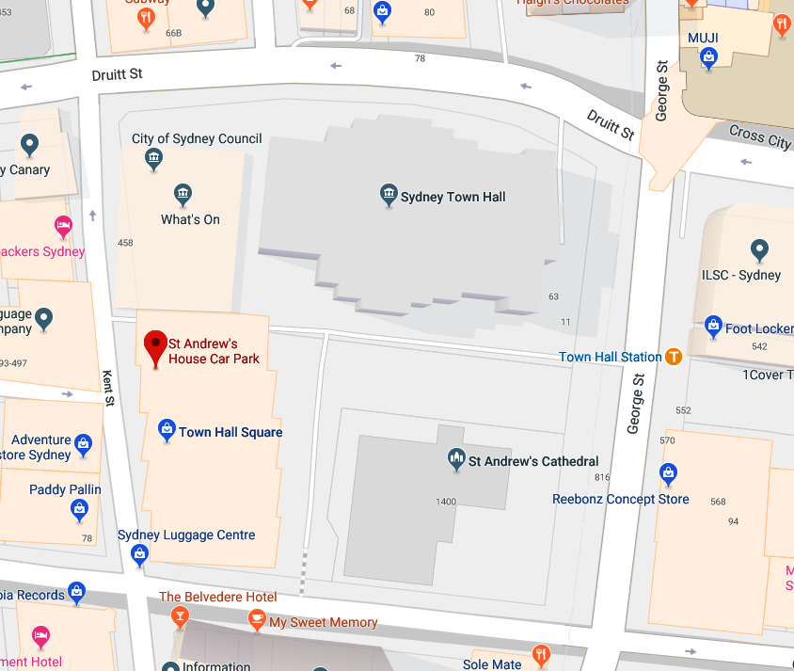

Venue and contact details:
Venue 2: Barker College (BARKER)
Contact person: Steve Augoloupis (Head Coach)
Email: steveaugoloupis@gmail.com
Phone number: 0434 818 877‬
Venue Address: , Rosewood Centre, Barker College - 9 The Avenue, Hornsby NSW 2077
Parking: Parking is available underneath the Rosewood Centre (Entry along Unwin Rd) or street parking nearby.
Public Transport: Waitara Train Station is nearby. 350m (approx. 5 min) walk.
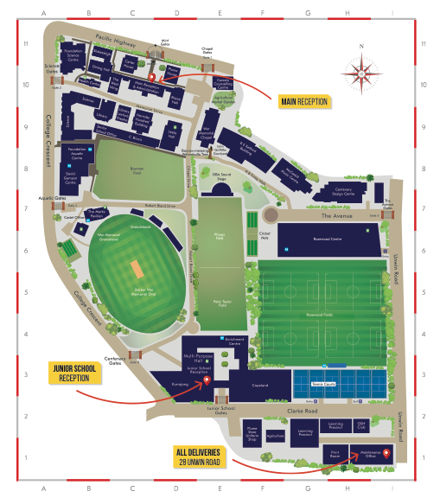
Rosewood Centre

Venue 3: Sydney Boys High School (SBHS)
Contact person: Dat Huynh (MIC Fencing)
Email: huynhd@sbhs.nsw.edu.au
Phone number: 0405 549 099
Venue location: SBHS GREAT HALL
Address: 556 Cleveland St, Moore Park NSW 2021
Parking: There is plenty of parking on site.
- via Cleveland Street – Gate 2
- via Anzac Parade – Gate 9
Public transport: Various bus routes and light rail nearby. Closest train station is Central Station.

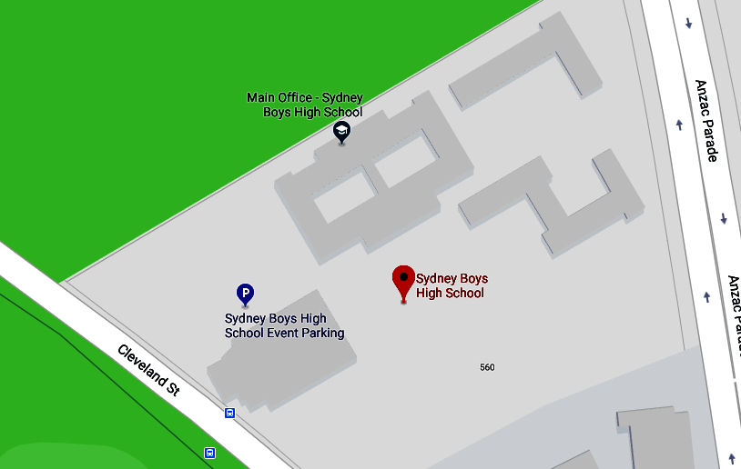
ENTER VIA GATE 9
FOR PARKING
Great Hall
ENTER VIA GATE 2
FOR PARKING

Venue 4 : OXLEY COLLEGE (OXLEY)
Contact person: Jeff Gray (Head Coach)
Email: jefence@tpg.com.au
Phone number: 0419 286 810‬‬‬‬‬‬‬‬‬
Venue location: Peter Craig Centre.
Address: 11-29 Railway Road, Burradoo, Bowral
Parking: There is plenty of parking on site.
Public transport: Burradoo Railway Station.

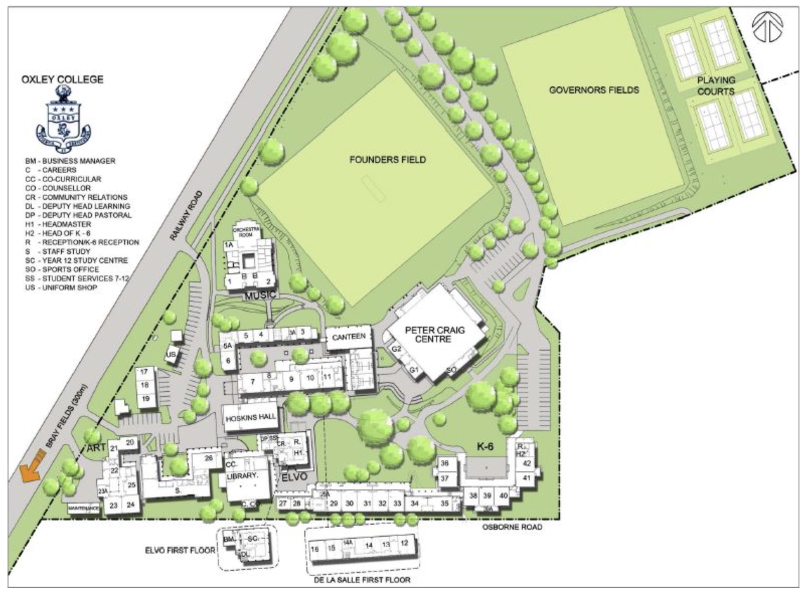
PETER CRAIG CENTRE

Venue 5: KNOX GRAMMAR SCHOOL (KNOX)
Location: Lawson Centre Courts
Address: 2 Borambil Street, Wahroonga, 2076
Contact: Luke Grant – grantl@knox.nsw.edu.au
Parking: Street parking on Woodville Avenue, Wahroonga
Public Transport: 3-5 minute walk from Wahroonga & Warrawee stations.

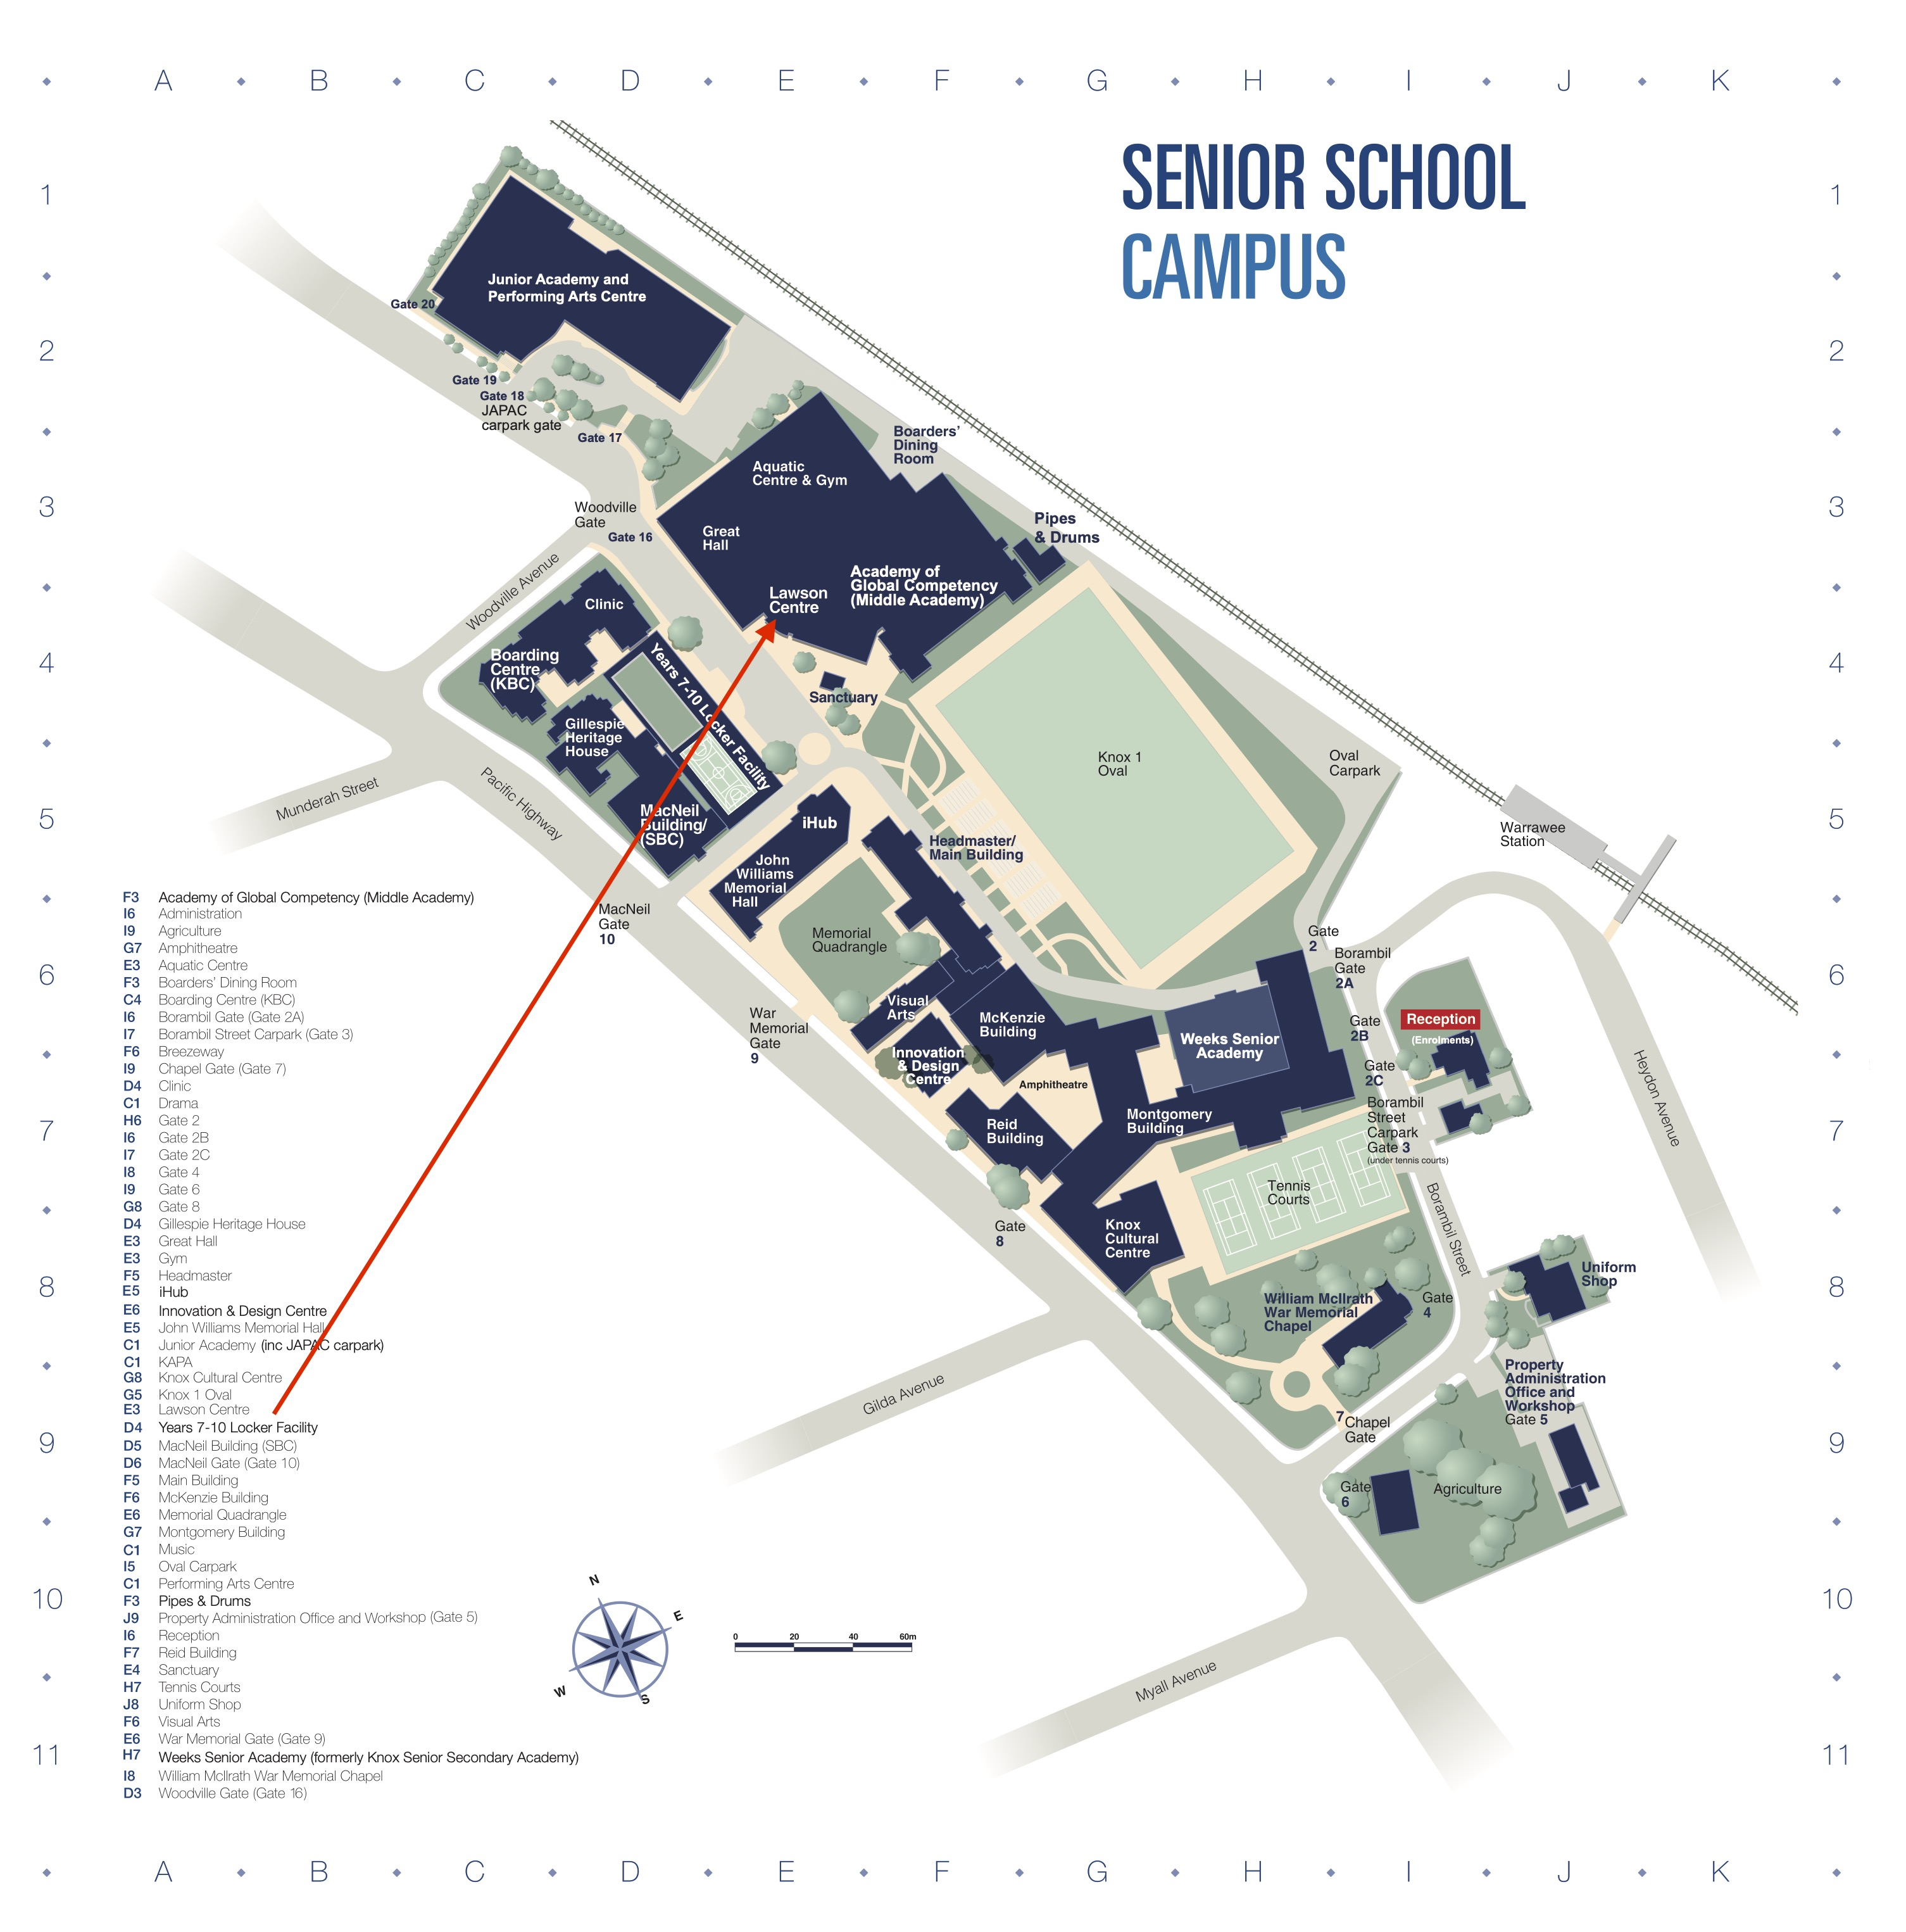

VENUE 6: St Aloysius' College
